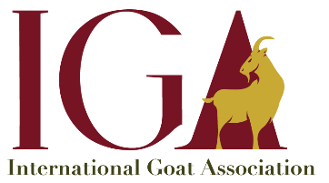
Membership year
(Check applicable box or boxes)

2021 ☐ 2022 ☐ 2023 ☐ 2024 ☐
2021 OFFICIAL INSTITUTIONAL MEMBERSHIP APPLICATION

Organization: Tap here to enter text.

Contact Name: Tap here to enter text. | Title: Tap here to enter text.

Address: Tap here to enter text.

City/State: Tap here to enter text. | Country/Zip Code: Tap here to enter text.

Telephone Number: Tap here to enter text. | Fax Number: Tap here to enter text.

Email: Tap here to enter text.

Institutional Memberships

☐ $250.00 USD per year – Ambassador
☐ $500.00 USD per year – Silver
☐ $1,500.00 USD per year – Gold
☐ $3,000.00 USD per year – Platinum

payment option: ☐ Credit Card ☐ Check ☐ Cash ☐ Wire Transfer
$ 00.00

Total amount enclosed (check) or to charge to credit card (Visa or MasterCard):

Credit Card Number (all digits)  xxxx xxxx xxxx xxxx | Expiration Date  month/year  mm / yy | Security code  xxx
Please make all checks payable to:  International Goat Association  12709 Grassy Dr.  Little Rock, AR 72210 USA | If you have further questions, please contact  admin@iga-goatworld.com or call 1-501-454-1641.

Signature: Tap here to enter text. | Date: Tap here to enter text.

